When developer trying to merge the code from feature branch to main branch, they have to raise a pull request in Github to pull the code to local and create another branch.

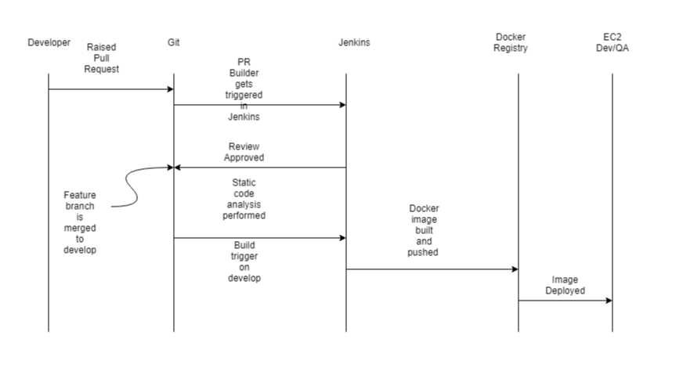

**Git Branching strategy :**

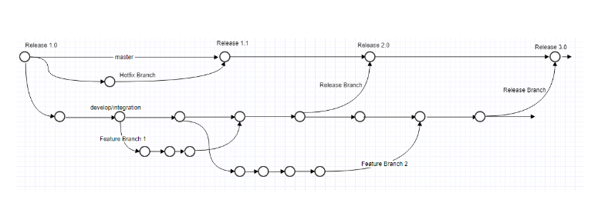

This is my develop branch

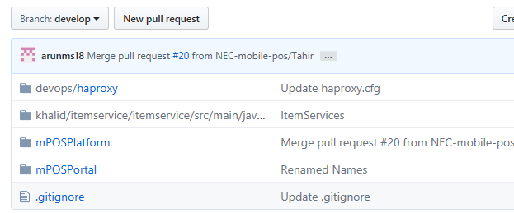

You have to modify any of the file in devlop branch and create a pull request as follows.

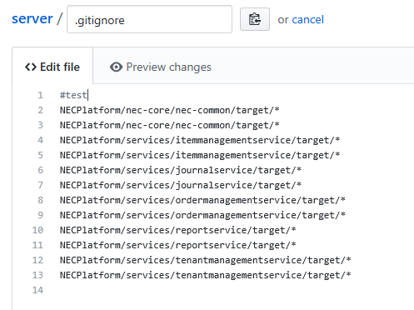

It will create new branch like below. While committing the changes it will show the below options. We are trying to pull the code from develop branch and creating new branch.

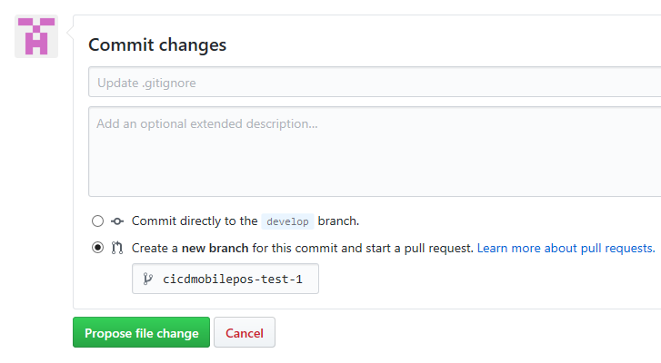

Click on propose file change button in the bottom.

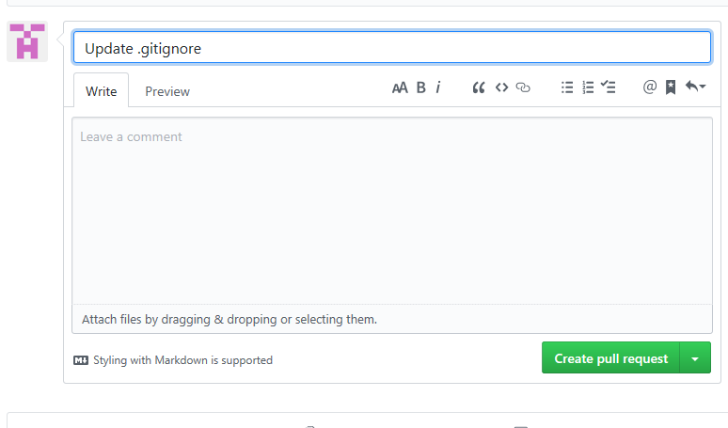

Click on create pull request.

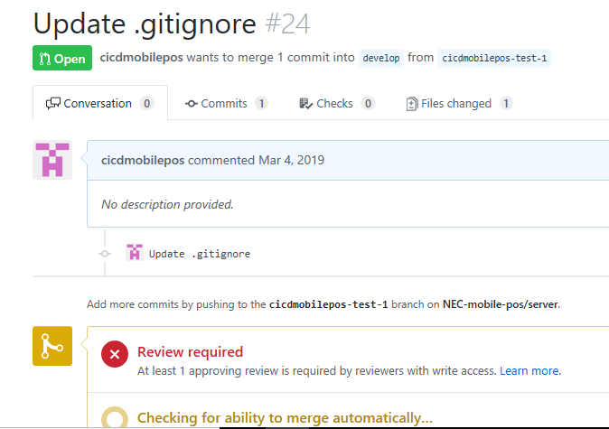

Once we raise the pull request Jenkins job will get trigger and it will do the static code analysis (sonar) on feature branch (cicdmobilepos-test-1)

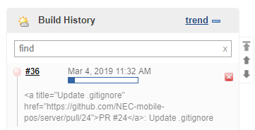

Once static code analysis is successful, the request will go to approver. Once it is approved it will merge to develop branch.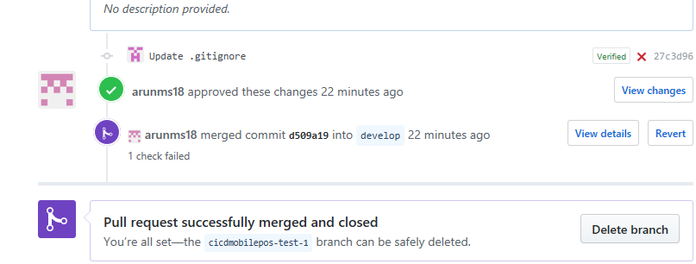

Since we already configured webhooks to trigger the jobs in Jenkins, jobs will trigger and creating the docker images and deploying to dev servers.



References:

<https://bhargavamin.com/how-to-do/sonarqube-analysis-git-pull-request-jenkins/>

<https://docs.sonarqube.org/display/PLUG/GitHub+Plugin>

<https://docs.sonarqube.org/latest/analysis/pull-request/>

<https://github.com/SonarSource/sonar-scanning-examples/pulls>

https://medium.com/@mreigen/integrate-jenkins-builds-into-github-pull-requests-33bc053d6210